Pioneer 2022 - TMS

Date: 6/5/25

Researcher(s): Alex Huynh
List the names of the team members contributing to the research.

Objective of research: Decision Making/Correlation with Scoring
Define the problem or research question you aim to address.

Notes

Cabrillo:
- Safety Equipment(Person)
  - Eye protection, face masks, eyewash stations, shower stations, first aid kits, and fire extinguishers.
- Safety(ROV)
  - Tether System - Master Fuse and Strain Relief Webbing
  - Edges covered by caps
  - Blue Robotics T200 Thrusters(4x) covered
  - Gripper(2x) has gear that removes objects above mechanical limit
    - ABS Filament
- Overview
  - Testing Electrical Housing through ANSYS then pool
  - 9.2 kg/Depth 15m/Aluminum & 3D Printing
  - Frame Goals: Modularity, Budget, Neutral Buoyancy, Ease of Use
  - Materials - Aluminum (Stiff Strong Cheap), excludes Carbon Fiber (Inflexible, affects buoyancy and expensive), PVC(Affects Buoyancy and Inflexible)
    - 3D Printing, then Machining, last resort CNC
  - Parts Placed to keep center of buoyancy in line of XY plane and above COM
  - Lifting handles(Human Convenience)/Skids(Friction Reduction)
  - Tether system that has strain relief and detachable
  - 1 Single Gearbox to house electronics
  - Used surfboard foam(secondary) and stainless steel floats for buoyancy
  - Ballast System for swift buoyancy adjustments
  - Pin Extractor(?) - unsure why
  - Buoyancy Engine using syringe plunger and servo system, and releases based on pressure
SW Virginia
- Frame - 3D Printing(PLA)/PVC Pipes(Light, inexpensive, durable, and replaceable)
- Tether - 50 ft, ethernet, airhose for buoyancy, rope for strain relief, and pool noodles to reach neutral buoyancy
- Thrusters(4x) - TriggerFish Four motor propeller kit
  - 2 Parallel
  - 2 mounted 45 degree angle
  - Ctrl-ed through Barracuda Ctrl Box Kit
- Buoyancy - Reached through flotation devices, such as PVC pipes, inner tubes ,and air hose
- Arms - made to bolt onto body, high infill for rigidity, parallel to each other, and tooth to prevent pins and ropes to slip out
  - Ctrl-ed through PS3 controller and ESPP32 board

Savanna Tech
- Frame - PVC/3D Printing
  - Octagonal w 3 rows of PVC for stability & attachments
  - Holes for Neutral Buoyancy
  - Cheap for Budget
- Thruster(6x) - covered, 2 thrust motors(Left/Right), 3 used for vertical
- Barracuda Kit modified
- Tether - 1 power & ethernet cable and 4 pneumatic hoses, and strain relief system
- Ballast System using Weights(Static)
- Vertical and Horizontal Grabber
- Pneumatics to stand to water pressure and no electrical shortage, run to grabbers
- Syringe connected to a balloon for buoyancy engine using latches and levers, inside a PVC, and timer
- Problems - Didn’t Sink(Used Static Ballast System) and Grippers not strong enough
- Safety - PPE and rounded edges
- Checklist for proper safety procedure
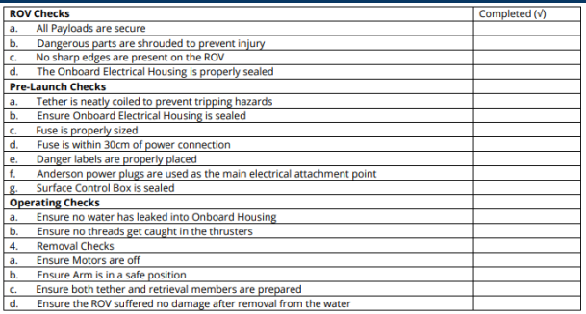
Pasadena:
- Frame - TriggerFish ROV Frame and PVC pipe
  - Trapezoidal and 45 degree vector design
- System Specifications
  - System specifications include:
  - - Must be able to fit in a 1 meter by 1 meter hole in the “ice.”
  - - Must weigh less than 35 kg (or 77 pounds).
  - - Vehicle must overcome 3 obstacles such as placing a fish into a bucket, replacing seagrass, and unhook the ghost nest.
  - - Materials compatibility requirements must be met to be used underwater.
  - - Do not exert a lot of force onto the ROV as there are limitations on the material.
- Thrusters(4x) - 2 motors (fwd/reverse) and yaw, 2 motors for Sway and Heave
- Arm Scooper, ABS Filament
- Safety - Waterproof, safety guards
- Tether - Strain Relief

Sources: Pioneer 2022 in MateROV folder

